**SANKEY CHART**

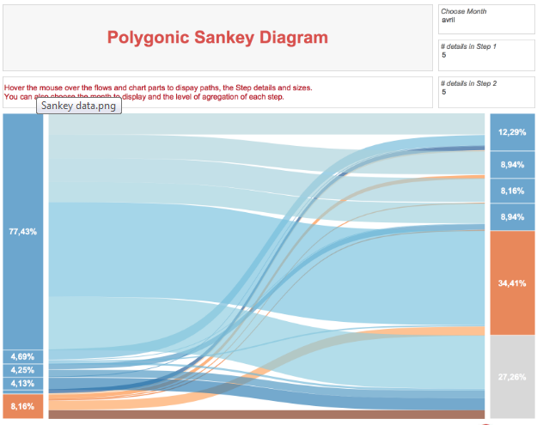

[**https://community.tableau.com/thread/152115**](https://community.tableau.com/thread/152115)

**RINGS CHART**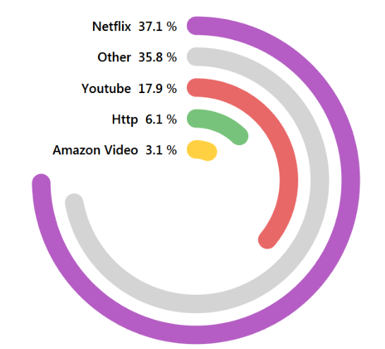

[**http://toanhoang.com/tableau-rings/**](http://toanhoang.com/tableau-rings/)

**CHORD DIAGRAM**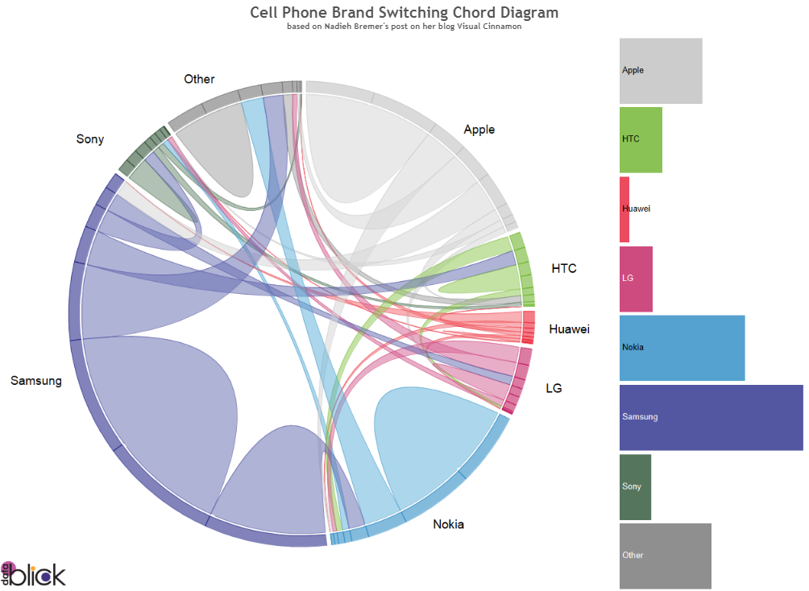

[**http://www.datablick.com/blog/2015/08/27/diy-chord-diagrams-in-tableau-by-noah-salvaterra**](http://www.datablick.com/blog/2015/08/27/diy-chord-diagrams-in-tableau-by-noah-salvaterra)

**SUNBURST CHART**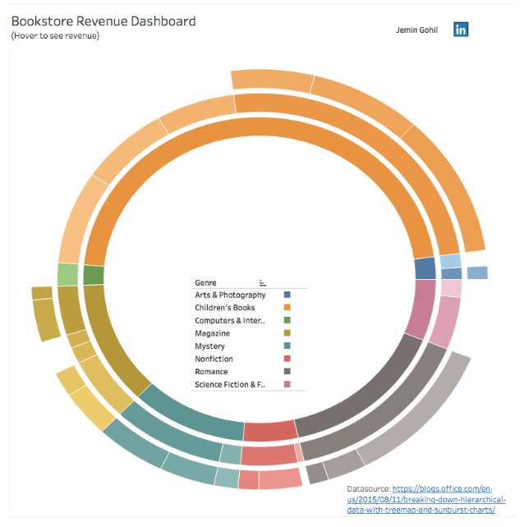[**https://community.tableau.com/thread/245139**](https://community.tableau.com/thread/245139)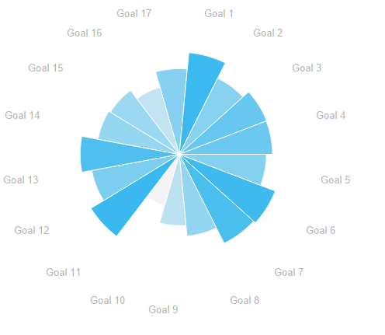

**Customizing tool tip**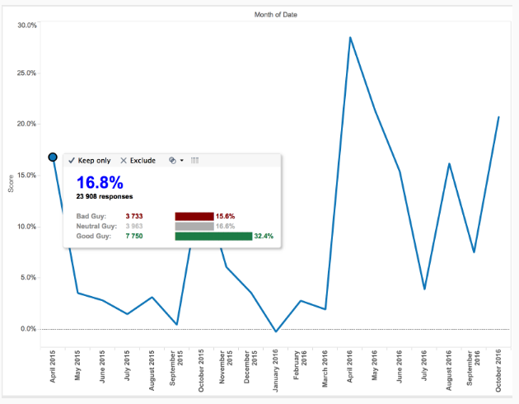

[**https://community.tableau.com/thread/223368**](https://community.tableau.com/thread/223368)

**RANK CHART**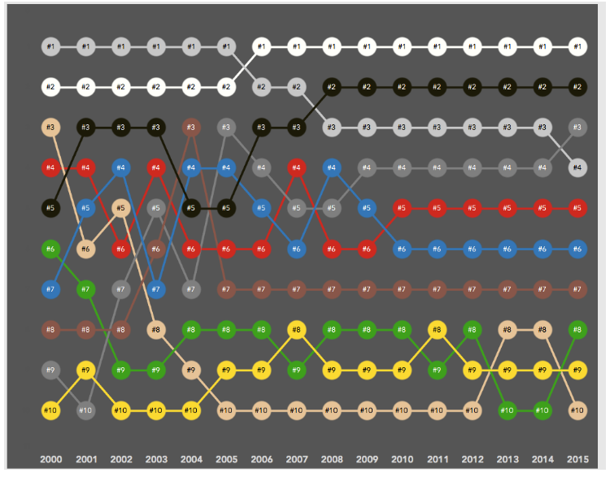

[**http://www.sirvizalot.com/2016/03/color-popularity-for-new-cars-2000-2015.html**](http://www.sirvizalot.com/2016/03/color-popularity-for-new-cars-2000-2015.html)

**DUMBBELL CHART**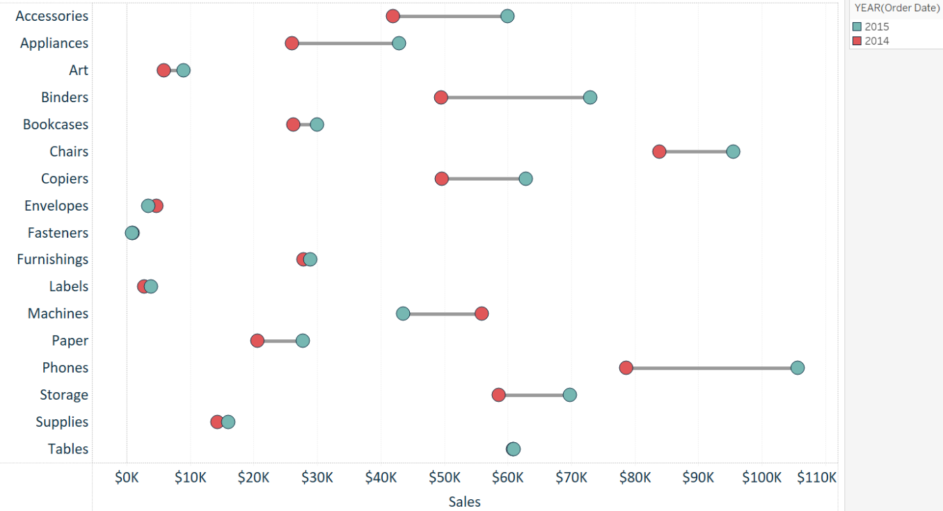

[**https://community.tableau.com/blogs/singh.rahul/2017/05/19/creating-a-dumbelldna-chart-in-tableau**](https://community.tableau.com/blogs/singh.rahul/2017/05/19/creating-a-dumbelldna-chart-in-tableau)